**IBCAST Copyright**

In order that the Proceedings of the International Bhurban Conference on Applied Sciences and Technology (IBCAST) may disseminate the WORK to the fullest extent, the author(s) hereby irrevocably grants, assigns, conveys, and transfers exclusively to the IBCAST the copyright in the WORK identified herein (including abstracts or summaries submitted with the WORK), under all laws, treaties, and conventions throughout the world in all forms, languages, and media now or hereafter known or developed without limitation in consideration of the publication of the WORK in the IBCAST. The author(s) warrants that the WORK in original, that it has not been published, that the copyright interest has not been assigned, or otherwise transferred to another party, and that permissions have been obtained and are attached for any portions of the WORK subject to another copyright. The authors shall indemnify the IBCAST and assigns for any and all claims, costs and expenses, including attorney’s fees, arising out of any breach of this warranty or other representations contained therein.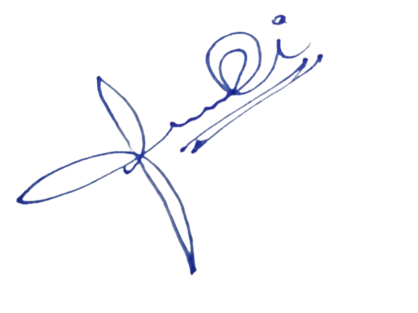

------------------------------------

Signature of the Author(s)